**Seaway App Documentation**

Adding Dealer Content

Step 1. Download/Clone current application repository

* Navigate to <http://www.github.com>
* Sign into website
* Open a new tab and navigate to <http://www.desktop.github.com>
* Click the download button and install the desktop client
* Create a folder on your desktop for your application (ie. “Dealer App”)
* In the Github Program, clone the desired repository to your desktop folder
* Download or Run your desired text editor (ie. Sublime, Notepad, Atom.io, etc.)
* 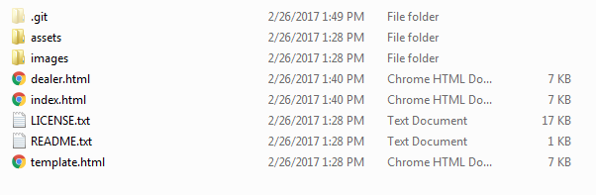Now you should see the application contents in the folder on your desktop
  + The index.html is the main seaway home presentation
  + Open the images folder. You will need to put all of your pictures in both the “fulls” and “thumbs” folders.
  + You will be editing the “dealer.html” file.
  + Right click on the “dealer.html” and choose “open with” and choose your desired text editor.
* Navigate to the following part of the website:

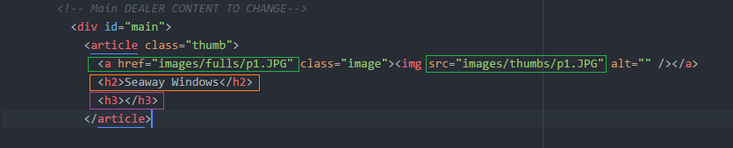

This part of the code is the logic for each slide in the presentation.

**[GREEN BOX]** Change the file path to link to the new image. Change the name in both green boxes.

**[ORANGE BOX]** This is the title of the slide. Change the text to whatever you need it to be.

**[PURPLE BOX]** This is sub-header text of the slide. Change the text to whatever you need it to be.

**REPEAT THIS STEPS FOR EVERY SLIDE THAT YOU NEED.**

**Commit changes and publish on Github program**

**– End of Documentation –**